**CHAPTER 5**

**_____________________________________________________**

**FUNCTIONAL BIOGEOGRAPHY OF THE THERMAL THRESHOLDS FOR EMBRYO GROWTH IN *CONOPODIUM MAJUS***

***_____________________________________________________***

**ABSTRACT**

*Conopodium majus* (Apiaceae) is a species with seeds that have morphological dormancy in which the development of the embryo is strictly controlled by temperature. There is no developmental arrest between embryo growth and germination. The species has an Atlantic oceanic distribution and its environmental plasticity defines it as an indicator of both woodlands and oligotrophic meadows. To date very few studies have approached the development of thermal models measuring the embryo development in a MD species and none have compared the regulation of embryo growth across the latitudinal distribution range of a species. Quantifying dormancy / germination in this way is therefore novel.

Nine populations of *Conopodium majus* were sampled across a latitudinal transect from Spain to Norway. The temperature control of embryo growth was investigated in the laboratory and in the field and compared with the local climate. Optimal temperatures for embryo growth and germination varied, across all populations, between 2.5 and 5.2 ̊ C, with ceiling temperatures between 12 and 20.5 ̊ C and base temperatures between -6.6 and -2.7 ̊ C. Germination in the field peaked in the months of January and February. The limiting factor to embryo growth related to higher temperatures and a significant correlation was described between the ceiling temperature and the bioclimatic environment of each population. In contrast, the optimal and base temperature were independent of local climate. The method used to characterize *C. majus* embryo development across its latitudinal range could give insights on how different scenario for predicted climate change can affect the regeneration of this species which is an important component of ancient woodlands in temperate Europe.

**KEYWORDS**

Cardinal temperatures for germination, Climate change, *Conopodium majus,* Embryo:endosperm ratio, Morphological dormancy

**INTRODUCTION**

The three aims of functional biogeography are to describe the distribution of functions along environmental gradients and across spatial scales; to use this information to explain the geographic distribution of organisms; and to predict their responses to environmental changes using trait-based predictive models (Violle et al 2014). A relevant aspect of plant function that has been underutilized by biogeographical studies is the physiological thermal control of plant reproduction (Bykova et al 2012), and especially seed germination. The temperature to which imbibed seeds are exposed affects their germination rate (Heydecker, 1977). This phenomenon can be described by the definition of the “cardinal“ temperatures, i.e., the optimum temperature (To), at which the germination rate is maximal and the base (Tb) and ceiling (Tc) temperature that are, respectively, the coldest and the highest temperature at which the progress towards germination occurs. The measurement of these temperatures for a given species enables prediction of seed germination rate under different temperatures and, using a thermal time approach (Covell et al., 1986; Ellis et al., 1986; Hardegree, 2006; Pritchard and Manger, 1990), to predict the germination timing of a given proportion of the population based on heat accumulated and the time spent between Tb and Tc. Therefore, the cardinal temperatures are key parameters to develop models that explain the contribution of regeneration environmental envelopes on species distributions and responses to climatic changes.

In many species however, seed dormancy prevents seeds from germinating even in the presence of suitable conditions, with the objective of avoiding the exposure of seedlings to unfavourable environmental conditions for their development. The depth of dormancy and the timing of its release can be regulated by physical factors, as is the case of species with a hard seed coat that is not permeable to water, by chemical inhibitors, and by temperature change (Probert, 2000). In particular, exposure of imbibed seeds to cold temperatures increases their response to gibberellic acids (Baskin and Baskin, 2014) and can reduce the requirement for other environmental signals (light, nitrate or temperature fluctuation) (Probert, 2000). In temperate environments, with a pronounced seasonality, the requirements for cold stratification can programme the seedlings to emerge after winter.

A particular case of seed dormancy occurs when the embryo is not completely developed and needs to grow to a critical size before germination can occur (morphological dormancy, MD) (Baskin and Baskin, 2014). Morphological dormancy is highly conserved in plant evolution (Forbis et al., 2002, Willis et al., 2014). Temperature is the main driver of morphological dormancy release, influencing the rate of development of the embryo, a mechanisms that allows the precise timing of germination (Stokes, 1952, Porceddu et al., 2017). The cardinal temperatures for the growth of the embryo can correspond or not with the ones for germination. In several species, such as *Aegopodium podagraria, Anthriscus sylvestris* and *Chaerophyllum temulum*, germination can occur over a wider range of temperatures after cold stratification has occurred (Baskin et al., 2000, Parthyal et al., 2009, Vandelook et al., 2007, Vandelook et al., 2009). Others like *Conopodium majus* and *Sanicula europaea* require a low temperature (5°C) both for embryo growth and germination (Chapter 4, this thesis; Vandelook and van Assche, 2008).

Biogeographical variation in several germination traits is well documented. For example, seeds of the tree *Aesculus hippocastanum* collected from across Europe had lower base temperatures for germination at the southern end of the distribution (Daws et al., 2004). The requirements for cold stratification can vary according to the local climate, as it has been demonstrated that populations from habitats with longer winters require a longer period of cold stratification compared with populations from milder habitats (Allen and Meyer, 1998). However, to our knowledge much less research has been dedicated to intraspecific variation in morphological dormancy and embryo growth. Mondoni et al. (2008) compared morphological dormancy between mountain and lowland populations of the temperate woodland forb *Anemone nemorosa*. Embryo size at dispersal was similar in all the populations. Nonetheless, embryo growth at cool temperatures was faster in the mountain population. This suggest a capacity of morphological dormancy to adapt to local conditions, either by local adaptation or phenotypic plasticity, analogous to that of physiological dormancy. Further research is warranted, to measure the thermal thresholds for embryo growth across wider geographical scales, and investigate whether they vary in association with environmental gradients. To our knowledge, a study on temperature regulation of embryo growth across the whole latitudinal distribution of a species has not being performed yet.

Previously, we demonstrated that seeds of the geophyte *Conopodium majus* have morphological dormancy, and that embryo growth and germination occur continuously at a narrow range of temperatures around 5 °C (Chapter 4, this thesis). Such narrow and low temperature requirements for embryo growth can offer several benefits to conduct a functional biography study of embryo growth. First, such precision in thermal control in a relatively wide latitudinal distribution (from Spain to Norway) can expose the species to shifts in its temperature germination niche in a scenario of changing climate (Walck et al., 2011). Second, since embryo growth and germination occur seamlessly, it is possible to develop a relatively simple model based on embryo growth as a response to temperature. Third, since the temperature range is so narrow it will be possible to consider the role of both Tc and Tb  in the regeneration niche.

In this study, data is presented on the functional biogeography of *Conopodium majus* in relation to the physiological thermal thresholds for embryo growth, a key reproductive process in many plant species. How these thresholds vary across the species distribution is assessed with the aim of testing the following two hypotheses:

1. Seed morphological traits and germination traits varies across populations sampled on a latitudinal transect;
2. Geographical and climatic factors can influence the requirements for embryo growth and germination in this species across its distribution.

**MATERIALS AND METHODS**

***Study species***

*Conopodium majus* (Apiaceae) is a geophyte with an European Atlantic distribution that ranges between Southern Spain to Central Norway (Tutin et al, 1968; <http://www.gbif.org>). As many *Apiaceae*, seeds of *C. majus* possess undeveloped, linear embryos (Martin, 1946) and germinate when they reach a length close to the full length of the endosperm (Chapter 4). For this reason, in this study the relative embryo size (embryo length/endosperm length, hereafter referred to as “E:E ratio”) is used to describe embryo development and germination capability is defined as the point at which the E:E ratio is ≥ 1, i.e., the embryo is now guaranteed to germinate under suitable conditions. In *C. majus*, germination has been observed to occur both at 0 and 5 °C with a similar rate of embryo growth (Chapter 4, this thesis). Such low temperature requirements are indicative of germination in winter. For species adapted to develop in woodlands as well as oligotrophic meadows, the control of the germination process in this way can constitute an adaptive advantage, allowing the seedlings to establish before the development of a tree canopy or of competing vegetation.

***Seed collection***

Mericarps of *Conopodium majus* were collected in the summer of 2016 from nine naturally occurring populations sampled across the western European latitudinal range of the species (Fig. 1).

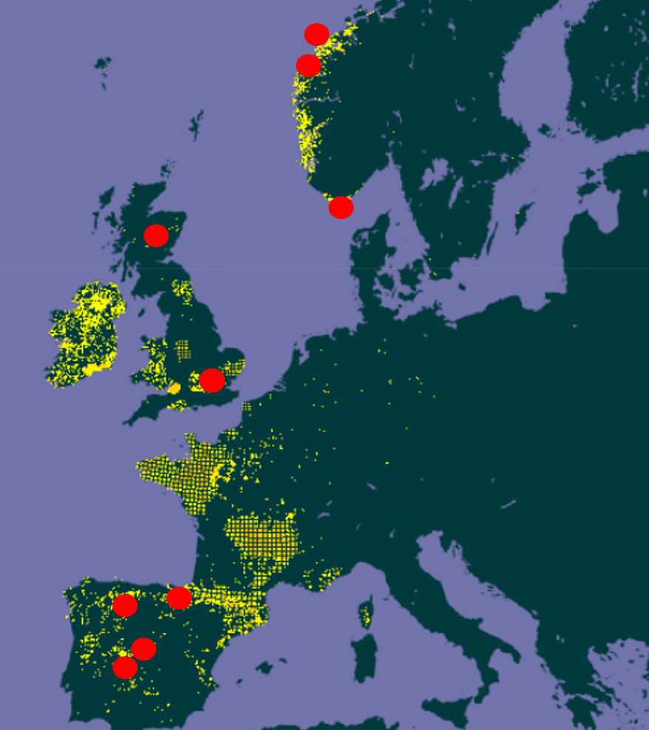

**Fig. 1:** Latitudinal transect across Europe of population samples used to study embryo growth in *Conopodium majus*.

Since the seed cannot be separated by the fruit in this species, the dispersal unit will be referred hereafter as a “seed”. A population was sampled only if it consisted of at least 200 individual plants. Seeds were sampled from 50 plants within the population to ensure a representative sample of the genetic variability of the population was secured. At least 4000 seeds were collected from each population. The two southernmost populations (coded “CHO” and “TRE”) used in this study were sampled in the Gredos mountain range, in central Spain and belonged to *Conopodium majus* subsp. *marizianum* (Samp.) López Udias & Mateo. Another population from the same subspecies (coded “LEO”) was sampled in the north of Spain on the Cantabrian Mountains. The nominal subspecies in fact only reaches the Pyrenean mountain range (http://www.gbif.org/) and was sampled in the Basque Country, Spain (“BAS”), south of England (“WAK”), Scotland (“SCO”), south of Norway (“FLE”) and central Norway (“BER” and “HER”) (Table 1). All seeds were collected between July and August 2016 and the experiments started within three weeks from seed collection. To avoid any change in morphological dormancy (by embryo growth at high humidity) seeds were kept at below full hydration under ambient condition on a laboratory bench until the beginning of the tests.

|  |  |  |  |  |  |
| --- | --- | --- | --- | --- | --- |
| Population | Country | Location | Latitude | Longitude | Altitude (m.s.l.) |
|  |  |  |  |  |  |
| HER | Norway | Herdla | 60 34'29.784'' N | 4 56' 53.627'' E | 37 |
| BER | Norway | Bergen | 60 20' 7.35 N | 5 22' 17.79'' E | 97 |
| FLE | Norway | Flekkeroya | 58 4'5.34'' N | 7 59' 53.56'' E | 19 |
| SCO | UK | Dalreoch Farm | 56 44' 47.36'' N | 3 32' 25.03'' W | 252 |
| WAK | UK | Wakehurst Place | 51 04' 12.79'' N | 0 05' 28.28'' W | 114 |
| BAS | Spain | Ondarre | 43 01' 42.8'' N | 2 03' 55.7'' W | 809 |
| LEO | Spain | El Tendero | 42 54' 26,62'' N | 5 49' 25,87'' W | 1426 |
| CHO | Spain | Central del Chorro | 40 18' 26.17'' N | 5 40' 09.39'' W | 1398 |
| TRE | Spain | Tremedal | 40 22' 00.5'' N | 5 37' 57.20'' W | 1555 |

**Table 1:** Provenance of seeds used in the experiments

***Initial measurements***

Each collection was cleaned from debris and empty seeds were removed using a gravity seed separator machine. From each population, 10 seeds were selected randomly and allowed to rehydrate overnight at 20 ̊C and 100% RH. The seeds were then placed on 1% agar-water for 24 hours to become fully imbibed and reactivate their metabolism. Thereafter, seeds were prepared for vital staining with 1% aqueous solution of triphenyl tetrazolium chloride (TZ). A slice of seed coat was removed from the dorsal surface of each seed using a scalpel and seeds were incubated in TZ solution at 30 ̊C in the dark for 24 hours. Each seed was then cut longitudinally and the embryo was extracted. Embryos and endosperms were photographed using a camera (Carl Zeiss Axiocam Colour) mounted on a Stemi SV 11 Microscope (Carl Zeiss, Welwin Garden City, Herts, UK) microscope and their lengths measured using the software Axiovision 3.1.2.1 (Carl Zeiss Vision GmbH). The initial relative embryo length was measured only for the seeds that stained red with the TZ, i.e., indicating viability; unstained seeds / embryos were discarded. Relative embryo size was used because it describes the growth of the embryo regardless the size of each seed.

From each population 100 seeds were placed in a controlled humidity room at 15% RH and left to dry. The dry seed weight of 100 replicates / individuals for each population was measured using a precision scale. The differences in seed dry mass and initial E:E across populations were represented with barplots (Figures 2 and 3).

***Embryo growth in controlled temperature conditions***

From each population and treatment, 16 subsamples of 15 seeds each were randomly taken and sown in separate, 8 cm diameter Petri dishes containing 1% agar-water substrate. Seeds were sown at -2.5 ̊C, 0 ̊C, 2.5 ̊C, 5 ̊C, 7.5 ̊C and 10 ̊C in incubators with a daily light regime of 12 hours of light and 12 hours of darkness. Every 14 days one subsample for each population and treatment was retrieved and the 15 seeds were placed for 24 hours in 1% TZ solution at 30 ̊C in the dark, after a slice of the seed coat was removed. From this subsample, the embryo and endosperm length of 10 viable seeds was measured. In this species the radicle emerges when the embryo is fully grown and has reached the same length as the endosperm. Therefore, an E:E value of 1 was assigned to all germinated seeds. Seed measurement was stopped when the seeds ceased germinating. The experiment continued for 224 days, until all the 16 subsamples assessments were concluded.

***Embryo growth in natural conditions***

Embryo growth in the soil was recorded for three population representing the southern (CHO), middle (WAK) and northern (BER) distribution of the species. The experiment was replicated in two locations where *C. majus* naturally occurs: at Wakehurst Place, England (site of collection of the “WAK” population); and in a meadow on the periphery of Bergen, Norway (close to the site of collection of the “BER” population). Sixteen subsamples of 20 seeds for each population and experimental site, were mixed with 20 g of soil collected at the site and passed through a 3 mm sieve. Seeds and soil were placed in mesh net bags and buried at a depth of 5 cm. A datalogger that recorded soil temperature every 30 minutes was placed in each location (Tinytag View 2, Gemini Dataloggers Ltd., Chichester. UK and EasyLog USB-2, Lascar Electronics, in Norway). The seeds were buried in England on 1st September 2016 and in Norway on 14th September 2016. Every 14 days a bag for each population was retrieved and the soil washed. Seed bags buried in Norway were shipped to England for measurements. All the seeds retrieved were prepared for TZ staining and their embryo and endosperm lengths measured. It was easiest to measure the seeds when most of the seeds were not germinated. With an increasing number of germinated seeds and seedlings, the amount of empty seed coats left in the soil bags made it difficult to distinguish between mouldy or germinated seeds. At this point, the experiment was terminated, representing nine measurements in Norway and thirteen in England.

***Calculation of a thermal model for embryo growth***

The average E:E ratio of 10 seeds for each population*temperature*time combination was calculated. All the temperatures for a same population had the same initial E:E ratio value a time of 0, while the maximum value was fixed at 1, after which the seed was considered to be able to germinate based on the evidence presented in Chapter 4. Since the data followed a sigmoidal growth distribution, except the treatments at -2.5 °C, a logistic model was fitted to each population * temperature combination using the software OriginLab 9.0. The models of each population were bounded between the initial value of E:E for that population and 1. A linear model was fitted to the -2.5°C treatments. From the equation of the logistic and linear models, it was possible to calculate the time expressed in days (tr) at which each temperature * population combination would have reached the following deciles of relative embryo size: 0.3, 0.4, 0.5, 0.6 and 0.7. Deciles < 0.3 could not be calculated because they were under initial E:E. Deciles > 0.7 were not calculated to keep the symmetry of the analyses regarding deciles of the population. For each treatment, the embryo growth rate was calculated as 1/tr.

For each population and decile, embryo growth rate was plotted against temperature. Each dataset was visually divided in a sub-optimal and supra-optimal range, using the point with the highest value of 1/tr as the dividing point. Liner regressions were fitted separately to the sub- and supra-optimal ranges. The intersection with the temperature axis of the sub-optimal and supra-optimal regression are, respectively, the base (Tb) and the ceiling (Tc) temperatures; these are the temperatures below and above which the embryo growth rate was equal to 0. The optimal temperature (To), defined as the temperature at which the rate of embryo growth is estimated to be fastest, is the x-coordinate of the intersection point between sub-optimal and supra-optimal regressions. Then, for each population, the cardinal temperatures (Tb, Tc and To) were averaged across all the deciles calculated to define an average value of the population (Ellis et al., 1986). The regression lines of each decile were recalculated and forced to pass through a common origin defined by the average Tb (for the sub-optimal regressions) or the average Tc (for the supra-optimal regressions) (Hardegree, 2006). For the three populations of *Conopodium majus* subsp. *marizianum*, only the cardinal temperatures calculated for the relative embryo size of 0.4, 0.5 and 0.6 were used, because it was not possible to fit a supra-optimal regression to the 0.3 decile.

The slopes of these new linear regressions were then taken as a reciprocal to estimate the sub-optimal (θb) and supra-optimal (θc) thermal time for embryo growth. θ, expressed in degree days (°Cd), indicates the amount of thermal time units above Tb (θb) or below Tc (θc) that the seed has to accumulate for the embryo to reach successive E:E deciles. For each population, the deciles were plotted against θb and θc, expressed both as their value and as the natural logarithm of the value, and linear regressions were fitted to the data. The regressions fitted to θ and to log(θ) were compared in each case by their R2 (Hardegree, 2006). The regression models with the highest R2 were chosen to represent the rate of embryo growth as a function of thermal time for each population.

***Validation of the model with field data***

In order to compare the embryo growth predicted by the determined thermal time model with embryo growth in natural conditions, embryo growth in the field sites was plotted against time. A logistic regression was fitted to these curves, and from the equations, the tr to reach every decile of relative embryo growth was calculated. The units of thermal time required by each population to reach every tr during the field experiment were calculated for both field locations using the data recorded by the loggers. In order to account for every temperature fluctuation during the day, the thermal time was expressed in “°C 30 min” and the heat accumulated by the seed was calculated for every 30 minutes data-logged. The difference (ΔT) between each temperature record and the population To (averaged between deciles) was summed. When the temperature was higher than the average Tc or lower than the average Tb the heat accumulated was considered = 0 and the difference (ΔT) between each temperature record and the To was summed.

The time necessary in the field to accumulate enough heat to reach the thermal time necessary for each tr was compared with the tr estimated from the embryo growth data. The time (in days) needed to sum enough heat to reach the θTb and θTc calculated in the model, for each tr decile (tr model) in each population was compared with the time needed by each population to reach the same decile of relative embryo growth in the field (tr field). These estimates were then graphically compared expressing the different tr in function of E:E (Fig.6).

***Relationship between embryo growth and germination***

Germination was scored for each independent sample before measuring the relative embryo size, and expressed as percentage of germinated seeds vs time. For each population, the germination data for the treatments at 2.5 and 5°C were fitted with the Boltzmann equation using the software OriginLab9. The other temperatures were not used because germination was too slow. For each population, from the fitted Boltzmann equation the day to reach 50% germination (tg50) was calculated. The tg50 was then used to calculate the corresponding E:E ratio at the same day using the logistic regression of the E:E data for the same treatment. For each population, the average E:E ratio corresponding to the tg50 for germination at the two temperatures used was displayed as the average E:E ratio for 50% germination in that population (Table 2). The average between all the populations represented the average for the species.

***Relationship between environmental data and germination traits***

The relationship between embryo development and seed germination traits and geographical and bioclimatic data was explored for each population. A data matrix was built including latitude, altitude, average annual temperature, precipitation of the driest month, average maximum temperature of the hottest month and minimum average temperature of the coldest month,seed dry mass, initial E:E ratio and cardinal temperaturesfor each population. Data was checked for autocorrelation using the Pearson correlation coefficient in order to exclude the variables with a strong autocorrelation. Finally a PCA was run on the dataset, scaling the axis (Fig.7).

**Results**

***Initial measurements***

The initial relative embryo size ranged from an average value of 0.10 (±0.29 SD) for the population BER to an average value of 0.19 (±0.29 SD) for the population CHO (**Fig.2).**

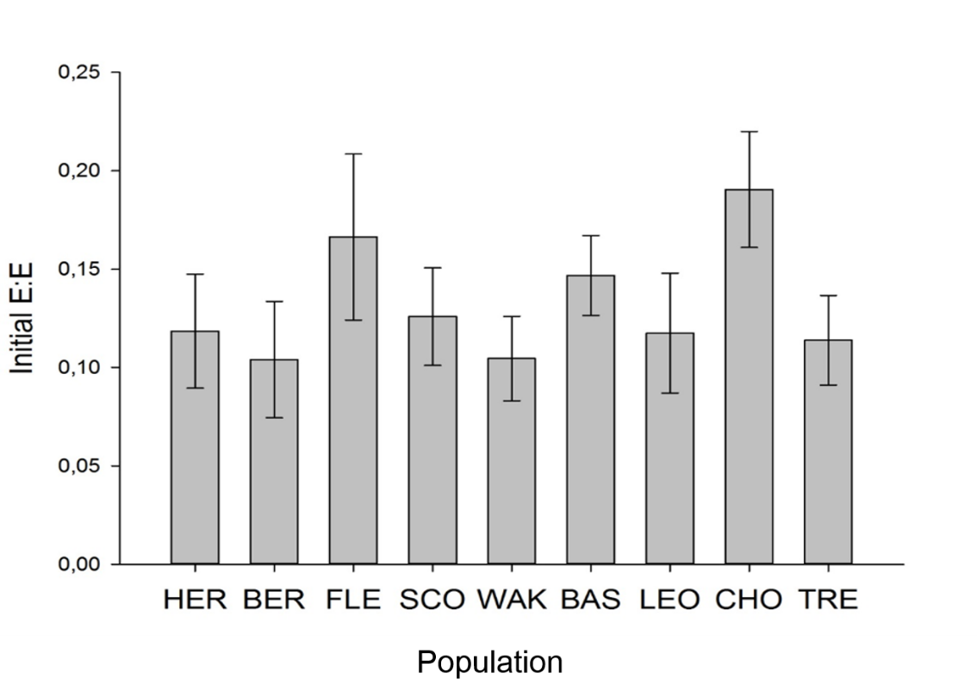

**Fig. 2:** Average initial E:E in seeds of all populations of *Conopodium majus* studied. Vertical bars indicate the standard deviations.

Average seed dry mass ranged just under two-fold from 1.20 mg (±0.38 SD) in TRE to 2.03 mg (±0.53 SD) in FLE (**Fig. 3**):

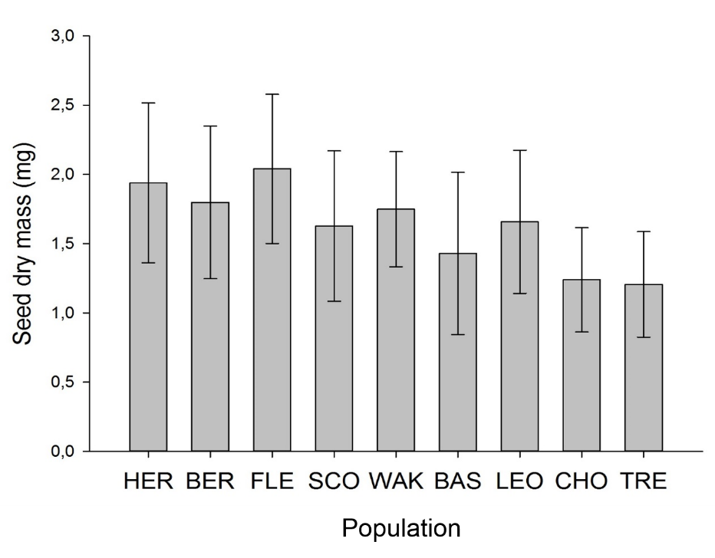

**Fig. 3:** Average seed dry mass for all populations of *Conopodium majus* studied. Vertical bars indicate the standard deviation.

***Embryo growth in controlled temperature conditions***

The seeds survived cooling to -2.5 C but the embryo did not grow at this temperature; while it can grow and germinate at 0 °C. The increase in embryo size in some populations at the -2.5 °C treatment was therefore due to temperature fluctuations in the incubator temperature, presumably beyond its specification (i.e., ± 2°C). The peak that was seen in this treatment for some of the populations occurred because of a fault of the incubator, when ice formation close to the ventilation system prevented air flow circulation leading to an increase in temperature. When the temperature of -2.5 °C was re-instated the growth of the embryo stopped again.

The rate of embryo growth was strictly dependent on the temperature and the increase in embryo size can be appreciated already after 14 days of imbibition. For all the populations, the temperature treatments with the highest rate of embryo growth were 2.5 and 5 °C. Clearly 0 °C is sub-optimal for embryo growth rate, and 7.5 and 10 °C were supra-optimal (**Fig.4**).

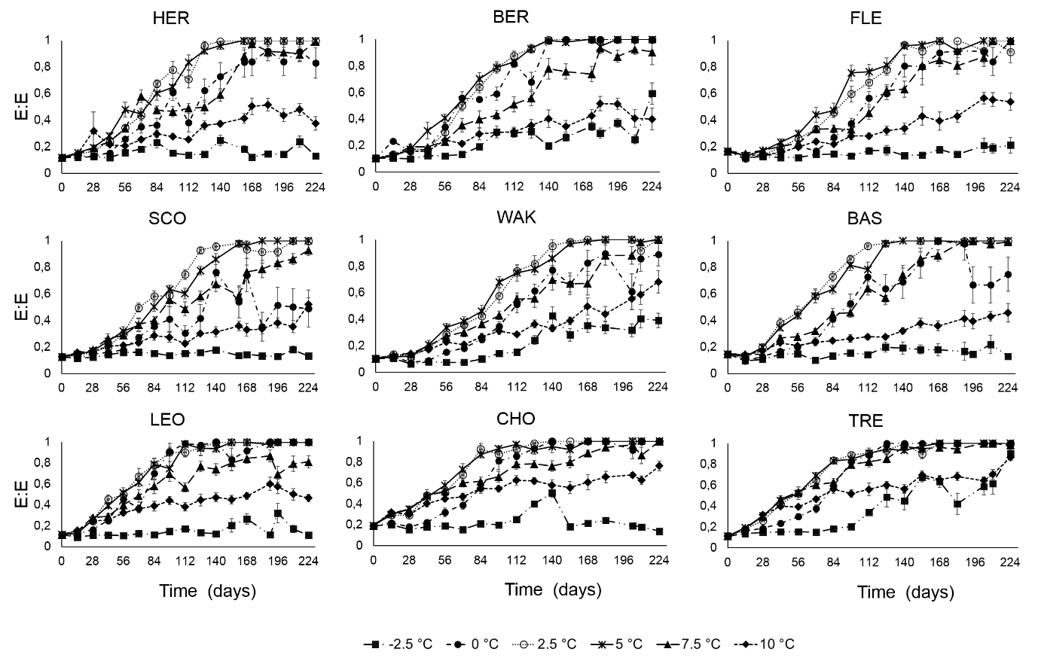

**Fig. 4:** Patterns of embryo growth (E:E ratio) for all the populations seeds of *Conopodium majus* and all temperatures tested. Each data point represent the average of ten replicate (± SE).

***Relationship between embryo growth and germination***

The first germination was seen after 84 days of imbibition in the four Spanish populations at the temperatures of 0, 2.5 and 5 °C. The populations from WAK and BER first germinated after 112 days of imbibition. The last population to begin germinating was SCO, after 126 days of imbibition.

Germination occurred when the embryo reached the same length of the endosperm (E:E=1) and an average E:E = 1 corresponded to 100% germination in the sample.

The treatments that, after 32 weeks of imbibition had the highest average germination across all the populations were 2.5 °C, and 5 °C with, respectively, 97.7 and 98.4 % of seeds germinated in the last sampling. The lowest germination was observed at -2.5 and 10 °C. The population that reached, across all the treatments, the highest average germination at week 32 (the end of the experiment), was TRE (80% ± 32 SD) while the lowest was achieved by SCO (59%, ± 42 SD).

The time to reach 50 % germination (T50g), interpolated with the Boltzmann equation ranged between 111 (BAS) and 147 (FLE ) at 2.5 °C and between 116 (LEO) and 150 (SCO) at 5 °C. The values of E:E corresponding to the estimated T50 (**Table 2**) in these two treatments were averaged between population and temperatures to describe a value of 0.89 ( ± 0.02 SD) for the species.

**Table 2:** Correspondence between the T50g and the estimated E:E ratio on this date for the two treatments (2.5 and 5 °C) that resulted in the highest germination.

|  |  |  |  |  |  |  |  |  |  |
| --- | --- | --- | --- | --- | --- | --- | --- | --- | --- |
|  | Population | 2.5 °C | 5°C | Population | 2.5°C | 5°C | Population | 2.5 °C | 5°C |
|  |  |  |  |  |  |  |  |  |  |
| T50g | HER | 123 | 126 | SCO | 133 | 150 | LEO | 115 | 116 |
| R2 Boltzmann | 0.99 | 0.97 | 0.99 | 0.99 | 0.99 | 0.95 |
| E:E at T50g | 0.89 | 0.87 | 0.87 | 0.88 | 0.91 | 0.89 |
|  |  |  |  |  |  |  |  |  |  |
| T50g | BER | 123 | 125 | WAK | 131 | 140 | CHO | 117 | 124 |
| R2 Boltzmann | 0.99 | 0.99 | 0.98 | 0.98 | 0.99 | 0.99 |
| E:E at T50g | 0.91 | 0.90 | 0.85 | 0.87 | 0.93 | 0.93 |
|  |  |  |  |  |  |  |  |  |  |
| T50 germination | FLE | 147 | 132 | BAS | 111 | 118 | TRE | 127 | 133 |
| R2 Boltzmann | 0.99 | 0.99 | 0.98 | 0.99 | 0.94 | 0.97 |
| E:E at T50g | 0.90 | 0.88 | 0.90 | 0.88 | 0.92 | 0.92 |

However, when interpreting this analysis it is important to consider that the original data of E:E ratio were based on averages of 10 individual seeds. This mean that at the T50g, only 50% of the seeds would have reached an E:E =1, corresponding to radicle protrusion, while the others would have had an E:E ratio lower than the average (Fig.4). The SD of the original data at T50g should then be taken into account when interpreting its correspondence with E:E ratio.

***Cardinal temperatures for embryo growth***

In the three populations of *C. majus* subsp. *marizianum* it was not possible to calculate the supra-optimal regression for the E:E 0.3 decile because, in the case of CHO and TRE there was no decrease in the embryo growth rate with increasing temperature (i.e., there were insufficient data points against which to fit the line) and, in the case of LEO, the regression had a very low slope that led to unrealistically high temperatures. Therefore, for these populations the cardinal temperatures were calculated on the average of the 0.4, 0.5 and 0.6 deciles.

The sub-optimal and supra-optimal regression lines fitted estimated Tb and Tc to vary between deciles (c.f. the same regression in which the line was forced to pass through a value of Tb and Tc that was averaged between deciles). Since the R2 of these last regressions was higher, the inverse of their slopes was used to define the thermal time at different deciles of embryo growth.

Between populations, Tb varied between -2.63 (SCO) and -6.65 °C (BER). In addition, To ranged from 2.54 (LEO) and 5.23 °C (CHO). Finally, Tc spanned 12.08 (BER) and 20.54 °C (TRE) (**Table 3**). Such low Tb means that the embryo growth of *C. majus* in its natural environment is limited by the higher temperatures because the low Tb for this species is seldom reached. Therefore, since the seeds are dispersed in late summer, there is no embryo growth until the temperatures drop in autumn. The relatively low Tc is, for this species, more indicative of environmental limitation for the embryo growth than is Tb.

**Table 3:**Cardinal temperatures averaged between deciles (± SD). In order to have a symmetric results around the middle value, if the lower deciles were excluded because too close to the initial embryo size, the higher ones were excluded too.

|  |  |  |  |  |
| --- | --- | --- | --- | --- |
| Population | Tb | To | Tc | Deciles used |
| HER | -4.01 ± 0.57 | 4.26 ± 0.80 | 12.90 ± 1.86 | 0.3 - 0.7 |
| BER | -6.65 ± 0.62 | 4.58 ± 0.02 | 12.08 ± 1.32 | 0.3 - 0.7 |
| FLE | -3.90 ± 0.14 | 4.50 ± 0.07 | 13.70 ± 0.71 | 0.3 - 0.7 |
| SCO | -2.63 ± 0.38 | 2.80 ± 0.25 | 14.42 ± 2.47 | 0.3 - 0.7 |
| WAK | -6.20 ± 0.89 | 4.59 ± 0.11 | 14.44 ± 1.72 | 0.3 - 0.7 |
| BAS | -2.75 ± 0.10 | 2.69 ± 0.10 | 13.07 ± 0.93 | 0.3 - 0.7 |
| LEO | -3.17 ± 0.06 | 2.54 ± 0.03 | 14.64 ± 2.23 | 0.4 - 0.6 |
| CHO | -4.09 ± 0.59 | 5.23 ± 1.05 | 20.48 ± 9.09 | 0.4 - 0.6 |
| TRE | -6.47 ± 0.41 | 4.86 ± 0.04 | 20.54 ± 7.25 | 0.4 - 0.6 |

***Model selection***

The R2 of the models obtained fitting embryo growth and log-normal (log °Cd) were slightly higher than the R2 of the model obtained using normal distributed thermal times (°C) (**Table 4**). The only exception was constituted by the population CHO, for which the best model fit was obtained using the non-transformed thermal time values, thus describing a linear increase of relative embryo size with accumulated heat.

**Table 4:** R2 of the linear models fitted to the relationship between E:E ratio and Ɵ or log Ɵ for the suboptimal and supraoptimal regressions across the deciles from 0.2 to 0.9 E:E.

|  |  |  |  |  |
| --- | --- | --- | --- | --- |
| Population | ƟTb | log ƟTb | ƟTc | log ƟTc |
| HER | 0.92 | 0.94 | 0.95 | 0.99 |
| BER | 0.99 | 0.99 | 0.90 | 0.98 |
| FLE | 0.96 | 0.99 | 0.96 | 0.99 |
| SCO | 0.95 | 0.99 | 0.94 | 0.99 |
| WAK | 0.97 | 0.98 | 0.93 | 0.98 |
| BAS | 0.95 | 0.99 | 0.95 | 0.99 |
| LEO | 0.94 | 0.99 | 0.93 | 0.99 |
| CHO | 0.97 | 0.95 | 0.97 | 0.93 |
| TRE | 0.96 | 0.98 | 0.94 | 0.97 |

***Embryo growth in natural conditions***

The minimum temperature recorded in Norway in winter was -2 °C in mid-November while the highest was recorded at the beginning of the experiment, on 15th September 2016 (18.5 °C). In England the minimum temperature recorded was 1.6 °C at the end of January and the maximum 17.0 °C, recorded on the same day as the Norwegian site, during an autumn heat wave. Embryo growth in natural condition was faster, for all the population tested, in the northern most location of Bergen where daily average temperatures were lower than at Wakehurst, UK. However, in both sites the rate of embryo growth started to increase when the temperatures fell below 10 °C (**Fig. 5**).

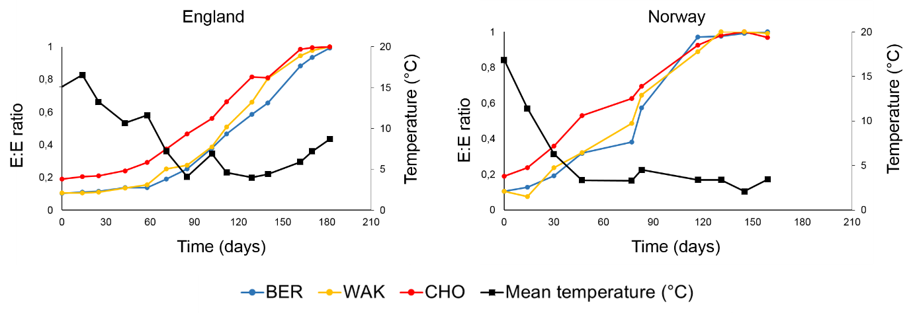

**Fig. 5:** Embryo growth in the field for buried seeds of *Conopodium majus*. Each data point represents the average E:E ratio of 20 seeds; soil temperature is also shown. The experiment started on 1st September 2016 in England and on 15th September 2016 in Norway. For each site, the experiment finished when all population reached 100% radicle emergence (corresponding to E:E =1).

Even if the southern population (CHO) had the greater initial E:E ratio, its growth rate was not different from the other populations tested. Eventually, the three growth curves tended to converge when an average E:E ratio approached 0.8 (**Fig. 5**). Germination in nature tended to peak in the months of January and February. Fitting a logistic regression to the curves permitted an estimation of the time, in days, to reach different deciles of relative embryo size (**Table 5**).

**Table 5:** Time, in days, estimated to reach different deciles of embryo growth in the two field locations for buried seeds of *Conopodium majus*.

|  |  |  |  |  |  |  |  |
| --- | --- | --- | --- | --- | --- | --- | --- |
|  | Norway (start 15th September 2016) | | |  | England (start 1st September 2016) | | |
|  |  |  |  |  |  |  |  |
| E:E ratio | BER | WAK | CHO |  | BER | WAK | CHO |
|  |  |  |  |  |  |  |  |
| 0.2 | 63 | 43 | 10 |  | 82 | 79 | 37 |
| 0.3 | 70 | 53 | 28 |  | 95 | 92 | 66 |
| 0.4 | 76 | 61 | 38 |  | 106 | 101 | 79 |
| 0.5 | 81 | 69 | 48 |  | 115 | 109 | 90 |
| 0.6 | 85 | 78 | 59 |  | 125 | 118 | 100 |
| 0.7 | 91 | 88 | 72 |  | 137 | 128 | 112 |
| 0.8 | 98 | 101 | 91 |  | 151 | 141 | 128 |
| 0.9 | 109 | 126 | 128 |  | 176 | 162 | 155 |

***Comparison of the model with field data***

The comparison of the thermal models against estimates of embryo growth in the field gave different results between the three populations, but was consistent between experimental sites (**Fig.7**).

Estimates of time to reach successive deciles of E:E ratio were similar if calculated using the ƟTb and ƟTc of the WAK population for both sites but higher than the Trg estimated from the logistic regression of embryo growth in the field. The BER population shown a rate of embryo growth that could be better predicted by the ƟTc rather than by ƟTb while both models diverged from the observed pattern of embryo growth in the southern population.

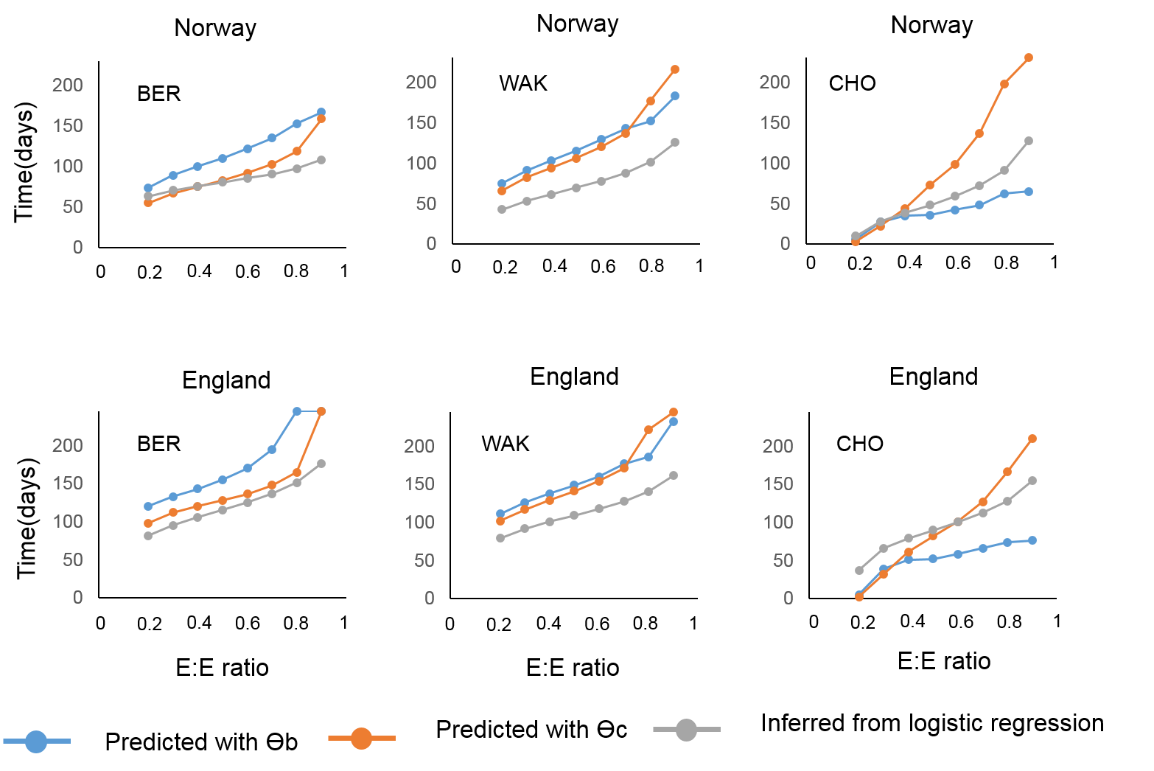

**Fig. 6:**Time (in days) required by each population of *Conopodium majus* seeds in each field location to reach different deciles of E:E ratio according to: 1) interpolation from the logistic regression of embryo growth in the field; 2) ƟTb; and 3) ƟTc obtained from the model.

***Environmental variability of germination traits***

Excluding the minimum temperature of the coldest month, all the other bioclimatic and geographical variables (altitude, latitude, precipitation of the driest month and maximum temperature of the warmest month) were correlated (Pearson coefficient > 0.7 or < -0.7). The base temperature (Tb) was negatively correlated with To (Pearson = -0.72) while the Tc had a positive correlation with initial embryo size.

A PCA (**Fig. 7**) ordered the populations according to their seed and germination traits and to the climate of the collection site. The first axis, that explained 50% of the variability in the data, separated the mountain, southern populations from the northern, lowland ones. The axis was described mostly by geographic and bioclimatic variables and the only seed traits that had a significant correlation with it were seed dry mass and Tc. In particular, there was a strong negative correlation between precipitations of the driest month and Tc. Mountain populations of *C. majus* were located in the southern portion of the distribution range of the species and were characterized by higher maximum temperatures and more severe drought stress. The seeds from these populations had a lower dry mass but a greater initial relative embryo size than the northern, lowland populations. The second axis explained 18.8 % of the variability in the data and had a significant correlation only with Tb and To. The two cardinal temperatures showed opposite trends, such that a higher optimum corresponded to a lower Tb.

The two southern most populations, CHO and TRE, remained separated from the others: they came from the highest altitude and experience the strongest heat and drought stress. The remaining populations can be separated in three groups: SCO, BAS and LEO had the highest Tb, HER and FLE the biggest seeds and BER and WAK had the higher To.

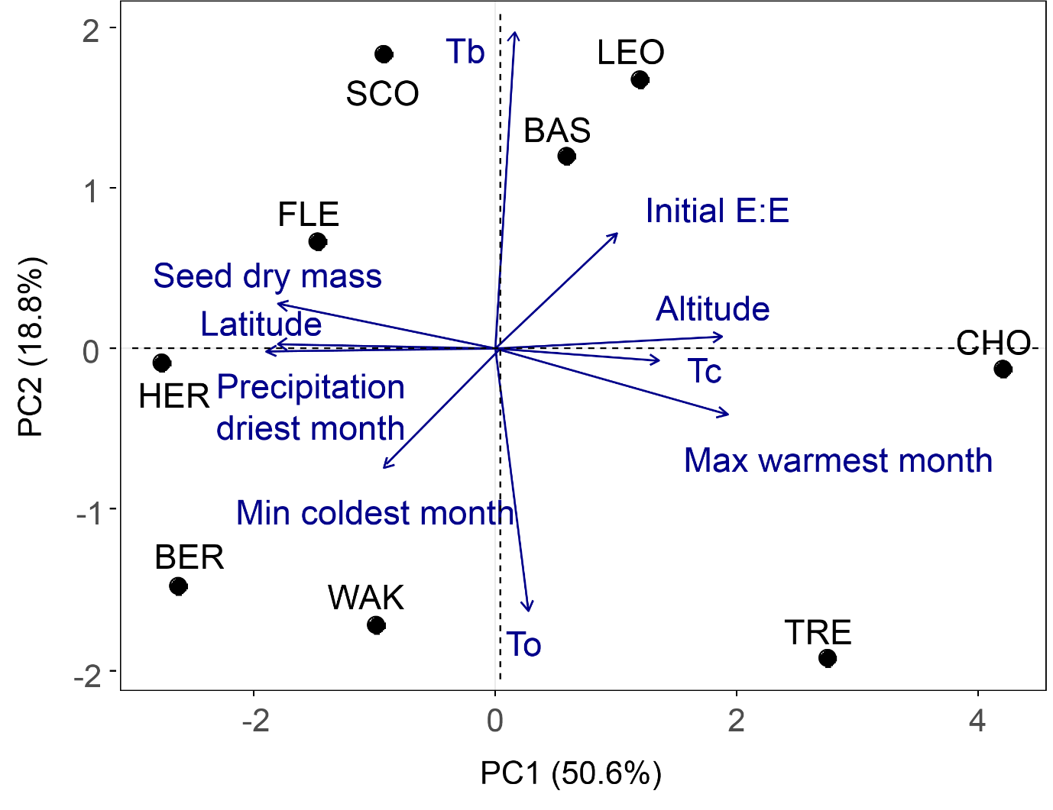

**Fig. 7:** Principal component analysis of seed traits in *Conopodium majus* and geographic and bioclimatic variables across Europe.

**DISCUSSION**

*Conopodium majus* shows considerable intraspecific variability in seed size across latitude. This has been observed for another species, *Sarracenia purpurea* (Ellison, 2001), with a similar seed morphology but with MPD rather than MD. Also, for *Sarracenia purpurea* the variation is seed size is not significantly affected by latitude. A positive effect of increased average annual precipitation on seed mass has instead been reported by Lemke et al., (2015) for the forest herb *Milium effusum* across a latitudinal transect in Europe. Also for *Conopodium majus*, the populations with average higher seed dry mass were the ones growing in areas not subject to drought or high temperature stress. A possible explanation of this trend is that plants that live in less stressful environment can afford to allocate more resources on seed production.

However, having heavier seeds does not translate into the presence of more developed embryos. In fact, the initial relative embryo size was higher for two populations representing the two extremes of our latitudinal transect: CHO, in central Spain and FLE in southern Norway. Moreover, these two populations also had the lightest (CHO) and the heaviest (FLE) average seed dry mass. While seed dry mass had a strong correlation with local climate the same cannot be affirmed for the initial relative embryo size, whose pattern of variation across populations seemed more random. In our ordination analysis, initial E:E ratio was not significantly correlated (p > 0.05) with either the first or the second axis of the PCA but was the only variable to be represented and significantly correlated with the third. Its variation is therefore independent both from the climate and geographic parameters and from the cardinal temperatures that define PC2 (**Fig. 7**).

The narrow temperature optimum for embryo growth in *C. majus,* already reported in Chapter 4, was confirmed by testing temperatures at a finer resolution. In all the populations the higher rate of embryo growth is at 2.5 and 5 °C while almost no growth happens at -2.5 °C. The standard deviation of the average E:E in seed samples incubated at 0, 7.5 and 10 °C is much higher than in the other treatments, especially towards the end of the experiment, when the average E:E approximates unity. Since these temperatures are further from the optimum for embryo growth but not so ‘stressful’ as to inhibit it, the increased standard deviation in the sample can be explained by a more heterogeneous response of the individual seeds to these conditions. In fact, some seeds, even though remaining viable (red staining at the TZ test and no apparent malformations) did not increase their embryo size at all at 0, 7.5 or 10 °C. But, while at the first two temperatures 100% of the seeds germinated eventually, embryo growth is too slow at 10 °C to culminate in germination during the 32 weeks of the experiment. Thus warmer winter temperatures in temperate forest environments as a result of climate change has the potential to inhibit the development of the embryo and thus negatively impact on germination and emergence of *Conopodium majus*.

All the populations considered are estimated to have a negative Tb, ranging from -6.7 °C in BER to -2.7 in BAS. Values of Tb lower than zero have been reported for some temperate trees, crops (mainly legumes) and wild plants but are not common (Durr et al., 2015). However, no values as low as -6.7 °C have been reported previously, the lowest being a Tb of -3.9°C for *Cryptantha minima* (Boraginaceae) and -4.5°C for *Krascheninnikovia lanata* (Amaranthaceae). The germination of *Cryptantha minima* at negative temperatures was explained by Wei et al., (2009) as an adaptation to take advantage of the water of the snowmelt in early spring and develop its annual cycle before the summer drought. In the case of *C. majus*, that is a perennial, this strategy could however offer some advantage at the southern range of its distribution, where summer drought can be a recurrent issue, as it has already been observed for Mediterranean subalpine species (Fernàndez Pascual et al., 2017). *Krascheninnikovia lanata* seeds show a positive effect of seed size on the ability to germinate at sub-zero temperatures (Wang et al., 2006). The authors demonstrate that bigger seeds had a higher concentration of sugars (glucose, raffinose and sucrose) that probably lower the freezing point of the seed tissues. There are no reports on sub-zero germination in Apiaceae but an optimal temperature for embryo growth of 2 °C has already been described for *Heracleum spondylium* (Stokes , 1953) and is not unlikely that this species, or others from the same family, could present equally low Tb for embryo growth. Field collected data (**Fig. 5**) and averaged climatic data from 2070-2000 (Fick and Hijmans, 2017) of the collection sites of the populations studied show that such low average temperatures are rare in the natural environment of *C. majus.* Therefore embryo growth is possible throughout the winter season and is limited by the higher temperatures in autumn. In fact, results from the ordination analysis (**Fig. 7**), showed that the Tb is independent from climatic and geographic factors and is not even correlated to seed size or initial E:E ratio. Therefore, as mentioned above, the limiting factor for this species is constituted by exposure to higher temperatures during the seed germination phase of the life cycle.

The optimum temperature for germination rate ranged between 2.5 and 5.2 °C (Table 3) and has a negative correlation with Tb, a phenomenon already reviewed by Durr et al., (2015). The second axis of the ordination analysis can therefore be interpreted as reflecting the width of the gap between Tb and To. The populations with the higher Tb (BAS, LEO and SCO) also have the lower To and therefore a narrower window of suboptimal conditions for embryo growth. Therefore, these populations are at greater risk of exposure to a reduced germination niche in the face of climate warming (Walck et al., 2011).

Tc varies between 12.1 and 20.5 °C and has a strong negative correlation with latitude and precipitation. Species from northern populations, that are less likely to experience long exposure to high autumnal temperatures, have lower values while the two southernmost populations, CHO and TRE, stand out for high Tc above 20 °C. Water stress is the main limiting factor for embryo development in these populations, that experience also a shorter winter and a more continental climate. The higher Tc can therefore be an adaptation to cope with higher daily fluctuations in temperatures that can prevent the embryo from growing during warmer, potentially desiccating parts of the day during late autumn or early spring. Moreover, embryo growth (and the potential to germinate) under cold (close to 0°C) will enable the start of growth during winter and emergence under the snow to avoid drought, as has been suggested to be the case for many sub-alpine species (Fernandez-Pascual et al., 2017).

**CONCLUSION**

In conclusion, *Conopodium majus* can be considered a model species for studying morphological dormancy due to its fine regulation of embryo growth by temperature and the coincidence between the temperature requirements for embryo growth and germination. To date only one study is known to have developed thermal models of embryo growth in a species of the Ranunculaceae family, *Aquilegia barbaricina* (Porceddu et al., 2017) and this work represents the first attempt to develop such a model on a species from Apiaceae family.The thermal models developed in this study can be used to predict shifts in its temperature germination niche caused by different climate change scenarios. However, *C. majus* also shows an adaptation to the climatic environment along its latitudinal distribution that are expressed by the breadth of the temperature germination niche indicated by the cardinal temperatures of each populations. Because of this phenotypic plasticity in the species the development of population specific model is more appropriate to describe and predict germination timing in this species. Finally, since for this species the Tc is more associated with the local climate than To and Tb, the use of the supra-optimal thermal time analyses are more appropriate when modelling a shift in germination niche due to climate change.

**AKNOWLEDGEMENTS**

The ideas behind this work was developed together with Eduardo Fernández Pascual. This study would not have been possible without the collaboration of Alvaro Bueno Sánchez, Joseba Garmendia, Luis Carlòn, Sylvy Sandvick, Giles Laverack, Maria Marin, and Brith Natlandsmyr that all helped with seed collection. We are especially grateful to Brith Natlandsmyr also for performing part of the experiments in her own garden and for her commitment to the project.

The involvement of Eduardo Fernández Pascual and Hugh W. Pritchard in revising the manuscript was precious and fundamental. The research leading to these results has received funding from the People Programme (Marie Curie Actions) of the European Union's Seventh Framework Programme FP7/2007-2013/ under REA grant agreement n°607785.

**REFERENCES**

Allen, P.S., Meyer, S.E., 1998. Ecological aspects of seed dormancy loss. Seed Science Research 8, 183-192.

Baskin, C.C., Baskin, J.M. 2014. Seeds. Ecology, biogeography and evolution of dormancy and germination, 2nd edition. Academic Press, San Diego, CA, USA, 1600 pp.

Baskin, C.C., Milberg, P., Andersson, L., Baskin, J.M. 2000. Deep complex morphophysiological dormancy in seeds of *Anthriscus sylvestris* (Apiaceae). Flora 195, 245-251.

Billings, W.D., Mooney, H.A., 1968. The ecology of arctic and alpine plants. Biological Reviews 43, 481-529.

Bykova, O., Chuine, I., Morin, X., Higgins, S.I., 2012. Temperature dependence of the reproduction niche and its relevance for plant species distributions. Journal of Biogeography 39, 2191–2200.

Covell, S., Ellis, R.H., Roberts, E.H., Summerfield, R.J. 1986. The influence of temperatures on seed germination rate in grain legumes. A comparison of chickpea, lentil, soybean and cowpea at constant temperatures. Journal of Experimental Botany, 37, 705-715.

Daws, M.I., Lydall, E., Chmielarz, P., Leprince, O., Matthews, S., Thanos, C.A., Pritchard, H.W., 2004. Developmental heat sum influences recalcitrant seed traits in Aesculus hippocastanum L. across Europe. New Phytologist 162, 157-166.

Dürr, C., Dickie, J. B., Yang, X. Y., & Pritchard, H. W., 2015. Ranges of critical temperature and water potential values for the germination of species worldwide: contribution to a seed trait database. Agricultural and Forest Meteorology, 200, 222-232.

Ellis, R.H., Covell, S., Roberts, E.H., Summerfield, R.J., 1986. The influence of temperature on seed germination rate in grain legumes. II. Intraspecific variation in chickpea (Cicer arietinum L.) at constant temperatures. Journal of Experimental Botany, 37, 1503-1515.

Ellison, A. M., 2001. Interspecific and intraspecific variation in seed size and germination requirements of Sarracenia (Sarraceniaceae). American Journal of Botany, 88, 429-437.

Fernández-Pascual, E., Jiménez-Alfaro, B., Bueno, A., 2017. Comparative seed germination traits in alpine and subalpine grasslands: higher elevations are associated with warmer germination temperatures. Plant Biology 19, 32–40.

Fick, S. E., & Hijmans, R. J., 2017. WorldClim 2: new 1‐km spatial resolution climate surfaces for global land areas. International Journal of Climatology.

Forbis, T.A., Floyd, S.K., De Queiroz, A., 2002. The evolution of embryo size in angiosperms and other seed plants: implications for the evolution of seed dormancy. Evolution, 56, 2112-2125.

Garcia-Huidobro, J., Monteith, J.L., Squire, G.R., 1982. Time, temperature and germination of pearl millet (*Pennisetum typhoides* S. & H.): I. Constant temperature. Journal of Experimental Botany 33, 288–296.

Hardegree, S.P., 2006. Predicting germination response to temperature. I. Cardinal-temperature models and subpopulation-specific regression. Annals of Botany 97, 1115-1125.

Heydecker, W., 1977. Stress and seed germination: An agronomic view. in The physiology and biochemistry of seed dormancy and germination. (ed) A. A. Khan. North-Holland, Amsterdam. pp 237-282.

Lemke, I. H., Kolb, A., Graae, B. J., De Frenne, P., Acharya, K. P., Blandino, C., Brunet, J., Chabrerie, O., Cousins, S.A.O., Decocq, G., Heinken, T., Hermy, M., Liira, J.,Schmucki, R., Shevtsova, A., Verheyen, K., Diekmann, M., 2015.Patterns of phenotypic trait variation in two temperate forest herbs along a broad climatic gradient. Plant Ecol. 216, 1523-1536.

Martin, A.C., 1946. The comparative internal morphology of seeds. American Midland Naturalist, 36, 513-660.

Mondoni, A., Probert, R., Rossi, G., Hay, F., Bonomi, C., 2008. Habitat-correlated seed germination behaviour in populations of wood anemone (Anemone nemorosa L.) from northern Italy. Seed Science Research 18, 213-222.

Mondoni, A., Rossi, G., Orsenigo, S., Probert, R.J., 2012. Climate warming could shift the timing of seed germination in alpine plants. Annals of Botany 110, 155–164.

Phartyal, S.S., Kondo, T., Baskin, J.M., Baskin, C.C., 2009. Temperature requirements differ for the two stages of seed dormancy break in *Aegopodium podagraria* (Apiaceae), a species with deep complex morphophysiological dormancy. American Journal of Botany 96, 1086-1095.

Porceddu, M., Mattana, E., Pritchard, H.W., Bacchetta, G. 2017 (in press). Dissecting seed dormancy and germination in *Aquilegia barbaricina*, through thermal kinetics of embryo growth. Plant Biology.

Pritchard, H.W., Manger, K.R., 1990. Quantal response of fruit and seed germination rate in *Quercus robur* L. and *Castanea sativa* Mill. To constant temperatures and photon dose. Journal of Experimental Botany 41, 1549-1557.

Probert, R.J., 2000. The Role of Temperature in the Regulation of Seed Dormancy and Germination. In Seeds: The Ecology of Regeneration in Plant Communities (Ed) M. Fenner. CABI, pp 261-292.

Shimono, Y., Kudo, G., 2005. Comparisons of germination traits of alpine plants between fellfield and snowbed habitats. Ecological Research 20, 189–197.

Stokes, P., 1952. A physiological study of embryo development in *Heracleum sphondylium* L.: I. the effect of temperature on embryo development. Annals of Botany 16, 441–447.

Stokes, P., 1953. A physiological study of embryo development in Heracleum sphondylium L. III. The effect of temperature on metabolism. Annals of Botany, 17, 157-174.

Tutin T.G. et al.,(eds) 1968. Flora Europaea: Volume 2. Cambridge University Press, UK.

Vandelook, F., Bolle, N., Van Assche, J.A., 2009. Morphological and physiological dormancy in seeds of *Aegopodium podagraria* (Apiaceae) broken successively during cold stratification. Seed Science Research 19, 115-123.

Vandelook, F., Bolle, N., Van Assche, J.A., 2007. Seed dormancy and germination of the European *Chaerophyllum temulum* (Apiaceae), a member of a trans-Atlantic genus. Ann. Bot. 100, 233-239.

Vandelook, F., Van Assche, J.A., 2008. Deep complex morphophysiological dormancy in *Sanicula europaea* (Apiaceae) fits a recurring pattern of dormancy types in genera with an Arcto-Tertiary distribution. Botany 86, 1370-1377.

Vandelook, F., Verdu, M., Honnay, O., 2012. The role of seed traits in determining the phylogenetic structure of temperate plant communities. Annals of Botany 110, 629–636.

Violle, C., Reich, P.B., Pacala, S.W., Enquist, B.J., Kattge, J., 2014. The emergence and promise of functional biogeography. Proceedings of the National Academy of Sciences 111, 13690–13696.

Walck, J.L., Hidayati, S.N., Dixon, K.W., Thompson, K., Poscholod, P., 2011. Climate change and plant regeneration from seed. Global Change Biology 17, 2145–2161.

Wang, R., Bai, Y., Low, N. H., Tanino, K., 2006. Seed size variation in cold and freezing tolerance during seed germination of winterfat (Krascheninnikovia lanata) (Chenopodiaceae). Botany, 84, 49-59.

Wei, Y., Bai, Y., Henderson, D. C., 2009. Critical conditions for successful regeneration of an endangered annual plant, Cryptantha minima: a modeling approach. Journal of Arid Environments 73, 872-875.

Willis, C. G., Baskin, C. C., Baskin, J. M., Auld, J. R., Venable, D. L., Cavender-Bares, J., Donohue, K., Rubio de Casas, R. and The NESCent Germination Working Group, 2014. The evolution of seed dormancy: environmental cues, evolutionary hubs, and diversification of the seed plants. New Phytol. 203, 300–309.

**Websites**

<http://www.gbif.org> accessed 6th June 2016